**Hands on 1**

**Spring Data JPA - Quick Example:**

**\\LOGES\Users\loges\eclipse-workspace\orm-learn**

**1. Create Spring Boot Project using Spring Initializr**

* Go to: <https://start.spring.io/>
* Set:
  + **Group**: com.cognizant
  + **Artifact**: orm-learn
  + **Description**: Demo project for Spring Data JPA and Hibernate
  + **Packaging**: Jar
* Dependencies:
  + Spring Boot DevTools
  + Spring Data JPA
  + MySQL Driver
* Click **Generate**, then extract the ZIP to your Eclipse workspace.
* **Import into Eclipse**

**2. Create MySQL Schema**

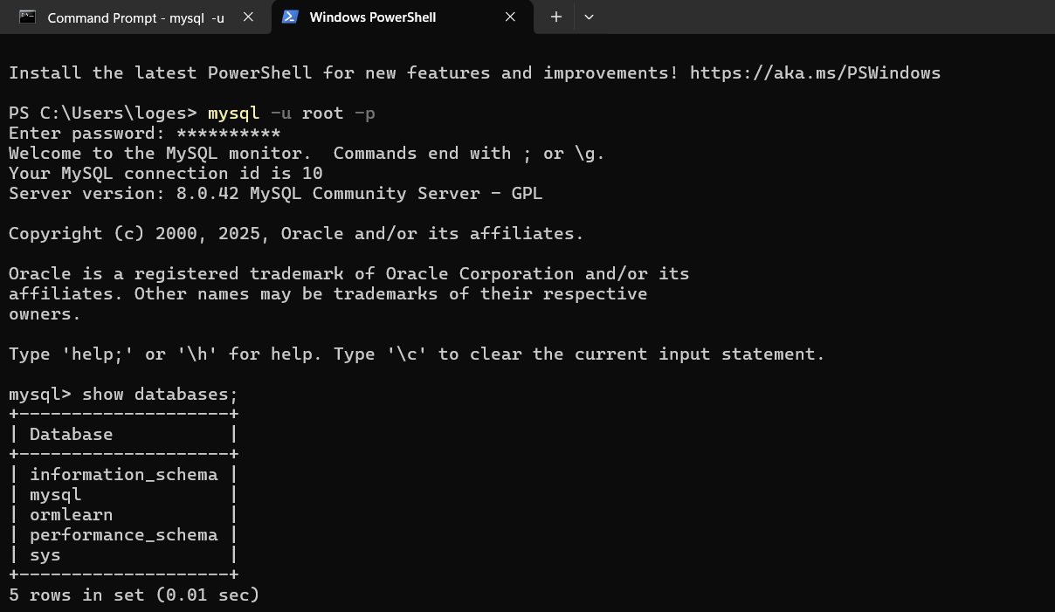

**3. Configure application.properties**

# Logging

logging.level.org.springframework=info

logging.level.com.cognizant=debug

logging.level.org.hibernate.SQL=trace

logging.level.org.hibernate.type.descriptor.sql=trace

logging.pattern.console=%d{dd-MM-yy} %d{HH:mm:ss.SSS} %-20.20thread %5p %-25.25logger{25} %25M %4L %m%n

# Database

spring.datasource.driver-class-name=com.mysql.cj.jdbc.Driver

spring.datasource.url=jdbc:mysql://localhost:3306/ormlearn

spring.datasource.username=root

spring.datasource.password=root

# Hibernate

spring.jpa.hibernate.ddl-auto=validate

spring.jpa.properties.hibernate.dialect=org.hibernate.dialect.MySQLDialect

Change username/password if your MySQL config is different.

**4. Build the Project**

mvn clean package -Dhttp.proxyHost=proxy.cognizant.com -Dhttp.proxyPort=6050 -Dhttps.proxyHost=proxy.cognizant.com -Dhttps.proxyPort=6050 -Dhttp.proxyUser=6404044

**5. Log Inside main() Method**

import org.slf4j.Logger;

import org.slf4j.LoggerFactory;

@SpringBootApplication

public class OrmLearnApplication {

private static final Logger LOGGER = LoggerFactory.getLogger(OrmLearnApplication.class);

public static void main(String[] args) {

SpringApplication.run(OrmLearnApplication.class, args);

LOGGER.info("Inside main");

}

}

**6. Country Table Creation in MySQL**

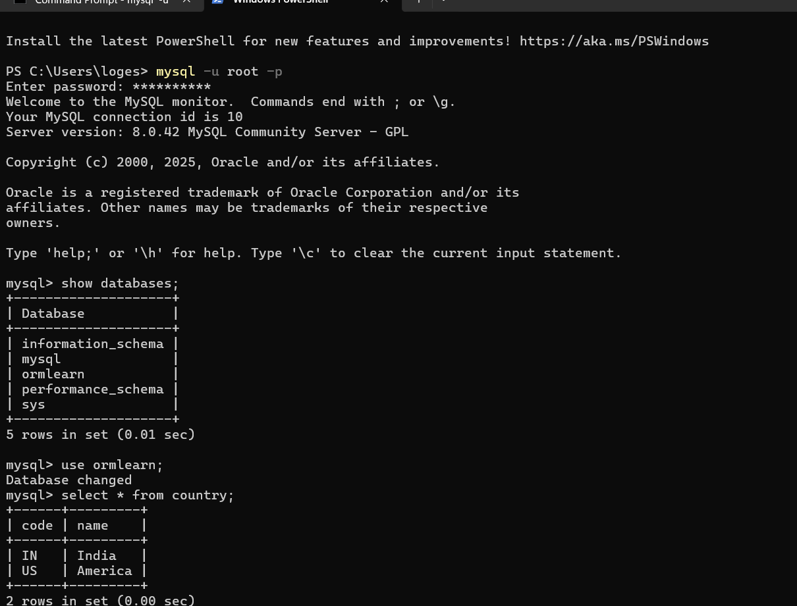

**7. Model Class: Country.java**

package com.cognizant.ormlearn.model;

import jakarta.persistence.*;

@Entity

@Table(name = "country")

public class Country {

@Id

@Column(name = "code")

private String code;

@Column(name = "name")

private String name;

// Getters and Setters

public String getCode() {

return code;

}

public void setCode(String code) {

this.code = code;

}

public String getName() {

return name;

}

public void setName(String name) {

this.name = name;

}

// toString()

@Override

public String toString() {

return "Country [code=" + code + ", name=" + name + "]";

}

}

**8. Repository Interface: CountryRepository.java**

package com.cognizant.ormlearn.repository;

import org.springframework.data.jpa.repository.JpaRepository;

import org.springframework.stereotype.Repository;

import com.cognizant.ormlearn.model.Country;

@Repository

public interface CountryRepository extends JpaRepository<Country, String> {

}

**9. Service Class: CountryService.java**

package com.cognizant.ormlearn.service;

import java.util.List;

import jakarta.transaction.Transactional;

import org.springframework.beans.factory.annotation.Autowired;

import org.springframework.stereotype.Service;

import com.cognizant.ormlearn.model.Country;

import com.cognizant.ormlearn.repository.CountryRepository;

@Service

public class CountryService {

@Autowired

private CountryRepository countryRepository;

@Transactional

public List<Country> getAllCountries() {

return countryRepository.findAll();

}

}

**10. Test the Service in OrmLearnApplication.java**

import com.cognizant.ormlearn.service.CountryService;

import com.cognizant.ormlearn.model.Country;

import org.springframework.context.ApplicationContext;

@SpringBootApplication

public class OrmLearnApplication {

private static final Logger LOGGER = LoggerFactory.getLogger(OrmLearnApplication.class);

private static CountryService countryService;

public static void main(String[] args) {

ApplicationContext context = SpringApplication.run(OrmLearnApplication.class, args);

countryService = context.getBean(CountryService.class);

testGetAllCountries();

}

private static void testGetAllCountries() {

LOGGER.info("Start");

List<Country> countries = countryService.getAllCountries();

LOGGER.debug("countries={}", countries);

LOGGER.info("End");

}

}

**11.Country Controller.java:**

package com.cognizant.ormlearn.controller;

import com.cognizant.ormlearn.model.Country;

import com.cognizant.ormlearn.service.CountryService;

import org.springframework.beans.factory.annotation.Autowired;

import org.springframework.web.bind.annotation.*;

import java.util.List;

*@RestController*

*@RequestMapping*("/countries")

public class CountryController {

*@Autowired*

private CountryService countryService;

*@GetMapping*

public List<Country> getAllCountries() {

return countryService.getAllCountries();

}

}

**11.Browser Output:**

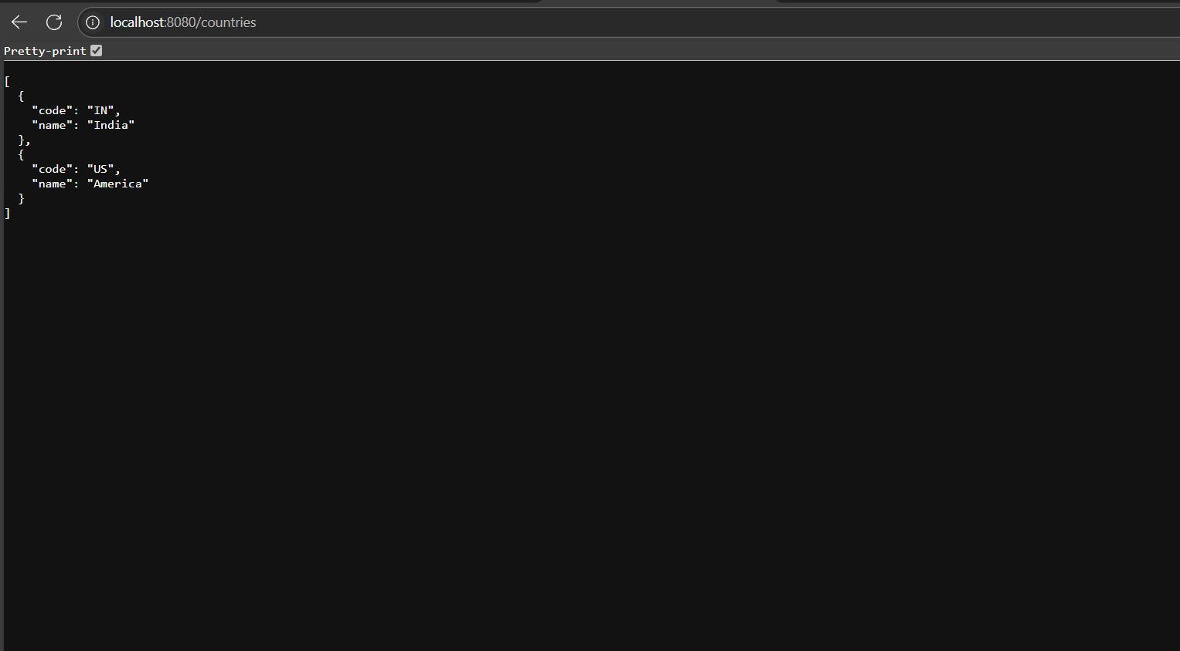

**12. Console Output :**

